

* **TITLE OF THE PROJECT**AUTOMATIC RAILWAY GATE CONTROL
* **CATEGORIES**
* **1.Micro controller project**

**2. IR sensor Project**

* **EASY HIGHLIGHTS**

**1.Minimise human intervention at railway crossing**

**2.Improve safety at railway crossing**

**3.Easy to make**

* **HARDWARE AND SOFT WARE**

**1.** . Arduino UNO (Or other)  
2. L293d motor driver ic or shild  
3. Two IR sensor  
4. one Dc geared motor 30 RPM  
5. 12volt Power supply (SMPS)  
6. A toy train  
7. A cardboard (as base)  
8. solder   
9. hot melt gun  
10. A buzzer  
11. A wooden or plastic rod for gate   
12. some wires, screw

* **ABSTRACT + DESCRIPTION(200-300 words)**
* In india, Railway crossings are manually operated . The information about arrival of locomotive for opening or closing of door is fetched from nearby railway station. But some railway level crossings are totally unmanned and many railway accidents occur at these unmanned level crossings.
* To minimise human intervention at railway crossings completely, we need to automate the process of railway gate control.
* This project deals with an efficient manner of automating the railway gate control where the gate is automatically opened or closed by sensing the arrival or leaving of the train.
* **WORKING PRINCIPLE (100-200 words)**

The mechanism of the project is very simple and is described here.

* Basically, the two IR sensors are placed adjacent side of the railway gate. The approximate distance between the two IR sensors is directly proportional to the length of the locomotive. For safety purposes, we have to consider the longest train in that route.
* Now let’s see how this circuit works in real time. In this picture, we can see the real time illustration of this project.
* [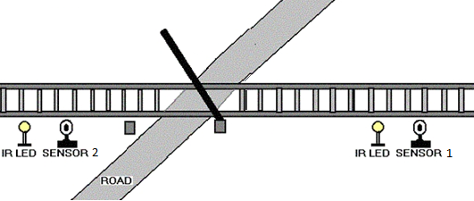](http://www.electronicshub.org/wp-content/uploads/2015/08/1.png)If the sensor 1 senses the incoming of the locomotive, microcontroller operates the motor using motor driver in order to close the crossing gate.

[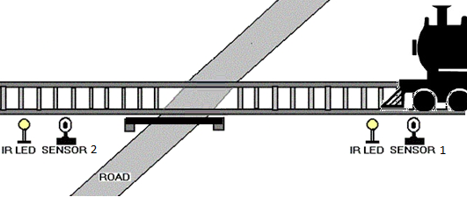](http://www.electronicshub.org/wp-content/uploads/2015/08/2.png)

* The gate remains closed as the locomotive passes the crossing.
* When the train crosses the gate and reaches second sensor, it senses the train and the microcontroller will open the gate.

[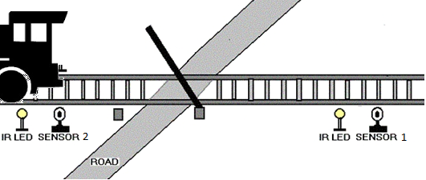](http://www.electronicshub.org/wp-content/uploads/2015/08/3.png)

